Week 5:

Topic: Ansible

Ansible is a deployment automation tool which uses push approach to achieve its objects By managing all the servers through a single server. Running the ansible configuration management tool.



Ansible Architecture:

Ansible connects to nodes and pushes out small programmers called modules. This module brings the desired state. Ansible uses SSH to execute these modules and then remove them when they are completed.

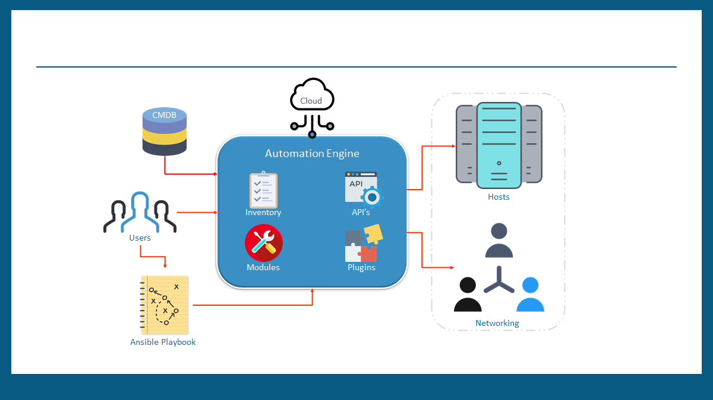

Ansible Installation:

Pre-requisites:

Step1:

Ensure python is installed on both the machines i.e Master and Slave, by default AWS Ubuntu images have python installed. You can skip this step if you are setting up ansible on AWS, on other machines install python using the following command.

Sudo apt-get install python3

Step2:

Enable keyless SSH access between Ansible Master and Slave. To accomplish this, do the following:

On Master follow the comand

ssh-keygen

Once you do that you will get your public key

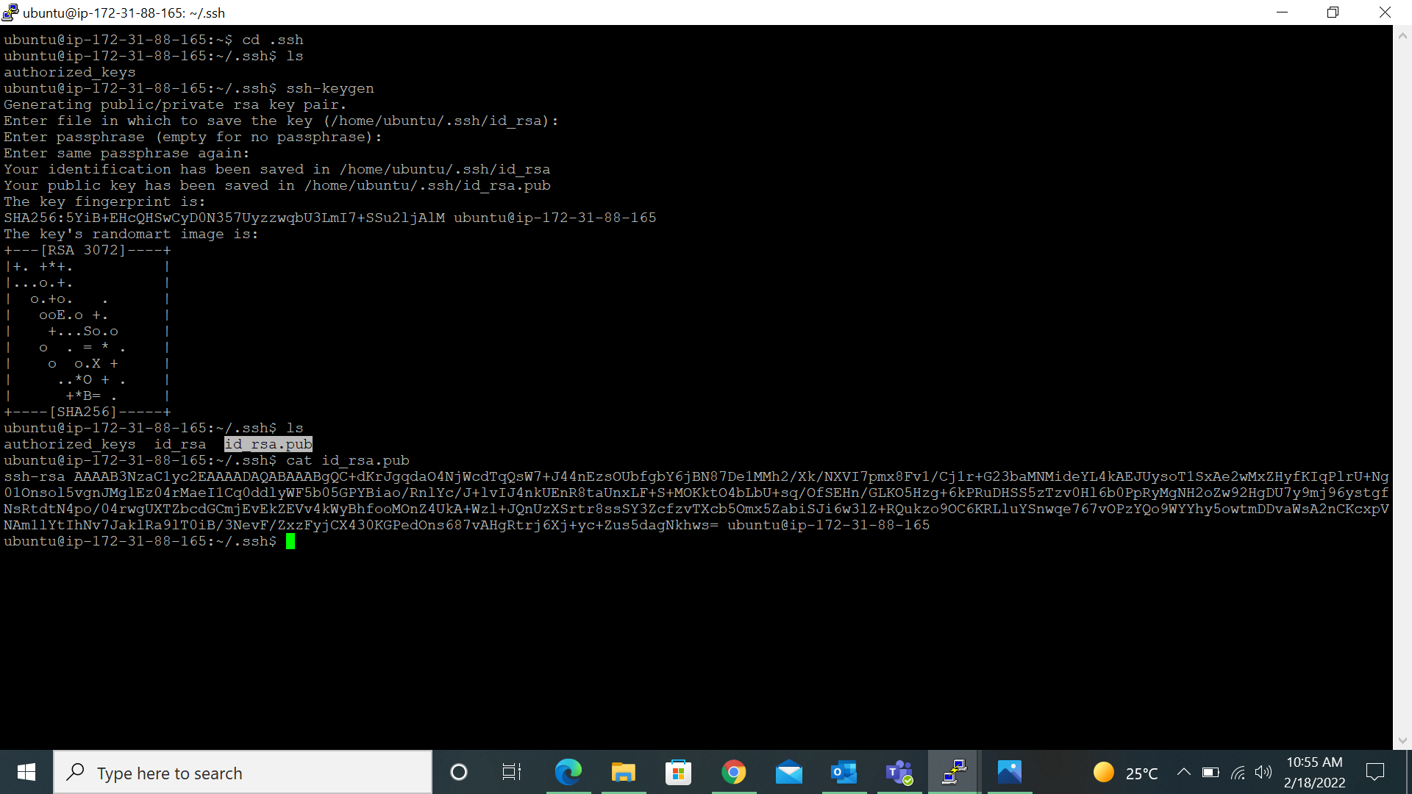

Step3:

Once you get your public copy that key and paste it in your slave machine inside .ssh if you type ls you will get authorized keys go inside init and copy the public key we generated in our master and paste inside authorized keys save it and exit.

Step4:

Once you have copied your key come to master and check whether your slave machine has been connected to the master machine or not

Step4:

Once your slave machine is connected to the master machine, exit from the slave and install Ansible on the master machine. To install Ansible follow the commands

sudo apt update

sudo apt install software-properties-common

sudo apt-add-repository --yes --update ppa:ansible/ansible

sudo apt install ansible

Next, configure the slave, by creating the hosts file in the master. To edit the file, pass the following command:

sudo nano /etc/ansible/hosts

Once inside enter the following syntax to add a slave. In this syntax, servers is the group and server1 is the slave machine’s name, you can give any name of your choice.

There will be some sample entries, you can ignore them and add the new values. With this, your ansible configuration is complete.

[servers]

server1 ansible_host=<slave ip address>

Step5:

Finally, you can test the ansible master slave connection by passing the following command:

ansible -m ping all



If everything, is configured correctly. You will get the above output.

By this we have done our ansible installation and connecting to the slave machine

Ansible Ad-hoc Commands

1. Ansible Ad-Hoc commands are used to accomplish tasks quickly
2. These commands are mostly used for one-off tasks
3. Ad-Hoc commands are handy to get small tasks done quickly

#### To Run ping command for all hosts

ansible all -m ping

#### To Run ping command to specific slave

ansible -i hosts <<slave>> -m ping

#### To Run any command on the slave machine

ansible -i hosts <<slave>> -m shell -a 'ls /home'

##### Let's install apache server on master server

###### run the command in /etc/ansible folder because hosts file is available there

ansible master -m apt -a "name=apache2 state=present"

##### let's verify it on the slave machine (it should be available)

systemctl status apache2

##### Now the service is present but it is not in started state on slave machine so lets Start the service on client using ansible on master machine

ansible mster -m service -a "name=apache2 state=started" Notice that State is changed=true

###### Check the status on client machine (it should be in active state)

systemctl status apache2

Ansible Playbook

Ansible Playbook book is a yaml script. It sends the commands to remote server in scripted way instead of using Ansible commands individually to configure remote server from command line.

Each playbook is an aggregation of one or more plays in it. Playbooks are structured using Plays. There can be more than one play inside a playbook.The function of a play is to map a set of instructions defined against a particular host. YAML is a strict typed language; so, extra care needs to be taken while writing the YAML files.

YAML:

It is data serialization language designed to be directly writeable and readable by humans

It is commonly used for configuration Management.

Strictly speaking YAML is a superset of json with additional features like indentation or new line

It is a case sensitive scripting language.

A YAML starts with --- (3 hyphens) (OPTIONAL)

##### Example

name: install and configure DB hosts: testServer

vars: oracle_db_port_value : 1521

tasks: -name: Install the Oracle DB yum:

1. yaml script

---

- name: play for running linux commands

hosts: webservers

tasks:

- name: to execute date command

command: date

register: output

- name: Printing value of output variable

debug:

msg: "{{ output.stdout }}"

2.yaml

---

- name: play for running linux commands

hosts: webservers

tasks:

- name: Install apache

apt:

name: apache2

state: present